Lab11：Memory Mountain

Requirements
Platform: This lab assumes that you are using Visual C++ under a 32-bit version of Windows, using Intel Pentium or Pentium-equivalent machines. The exact compiler and platform are mostly unimportant, as the lab is reasonably portable.

Get to know your Cache
This platform of Intel Pentium machines has a memory hierarchy, which includes multi level of Cache, such as L1 cache, L2 cache, and sometimes L3 Cache maybe also exist.
You can use the some tools, such as everest.exe, to find out the basic information of Cache of the computer system, which you are uings.
For example, to using everest.exe, just double-click to run it. After it makes some information collection, it will show all the information about you computer system in its frame.
The following is an example of its main frame. You can see the information about the Cache.
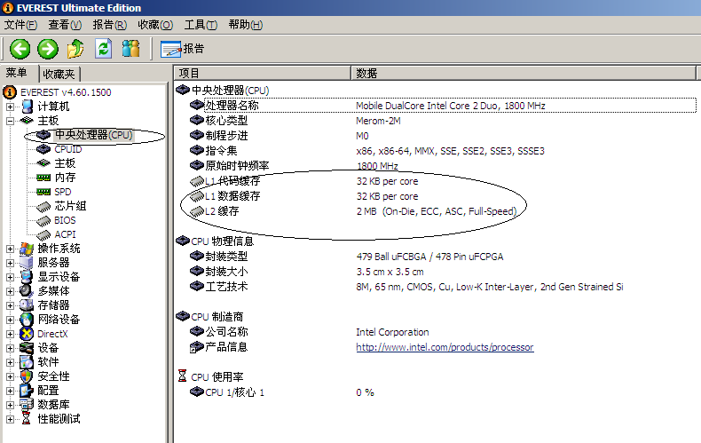

Now, run everest.exe to find out the information of your computer system’s Cache, and fill the blank.
Type | Size in byte
L1 cache | 32KB
L2 cache | 256KB
L3 cache | 4MB
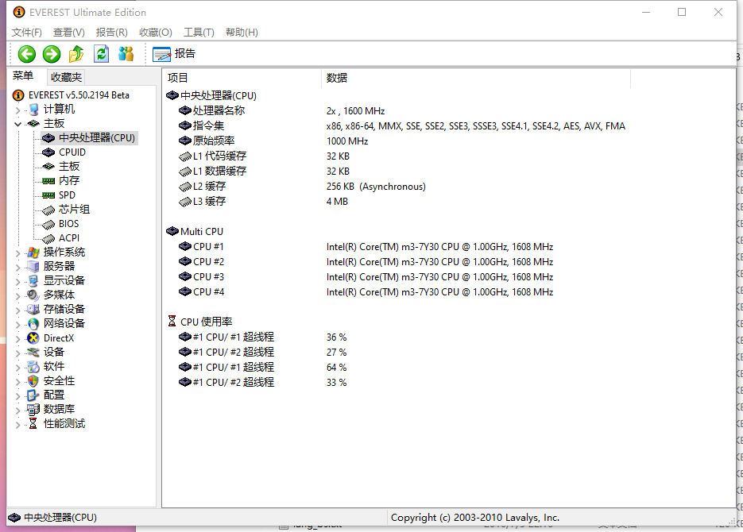

The project of memory_mountain
Please download the project of memory_mountain.rar first.
This project if the Windows-version of CMU CSAPP of mountain.c, which you can find in
- the textbook chapter 6.6(Notes: this is the first version),
- or from http://csapp.cs.cmu.edu/public/1e/public/code.html/mountain.c(Notes: this is the first version)
- or from http://csapp.cs.cmu.edu/public/code.html/mountain.c(Notes: this is the second version)

Your Task
1．Read the source code in mountain.cpp, and answer the following questions: (Notes: you don’t have to pay too much attention on the function fcyc2() )
1) What is the variable of size and stride used for?
size：一次读取的内存数据的大小
stride：读取一级缓存数据时，读取的字节的间隔大小

1) What is the meaning of the return value of the function run()?
返回值是吞吐量，单位MB/S

2．If necessary, make some change to the value of MINBYTES, MAXBYTES, and MAXSTRIDE.
3．Build the project and run it, the you can get an output file named as out.txt.
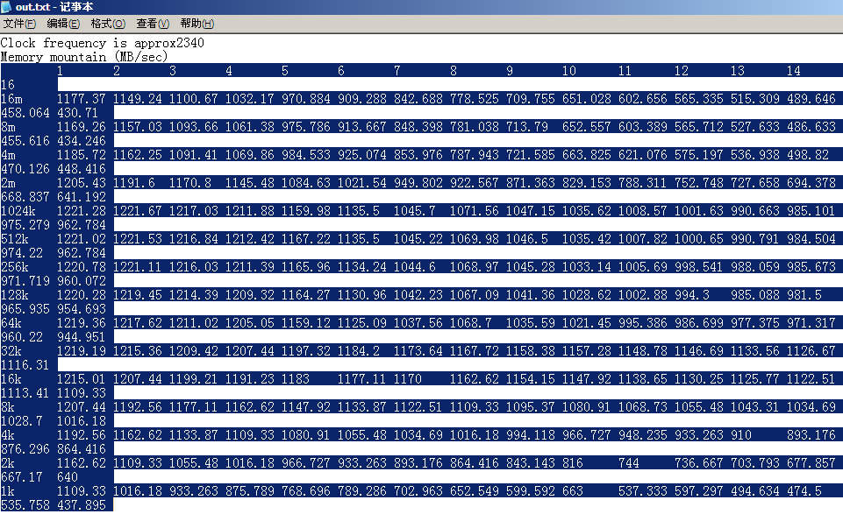
4．Copy the data in out.txt into an Excel file. Just as shown in the following figure.
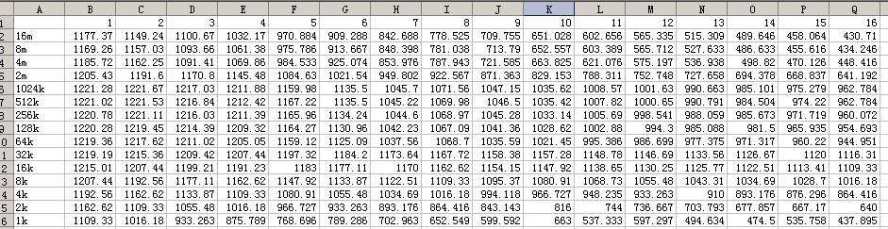
5．Click any cell in this Excel file, then add a chart.
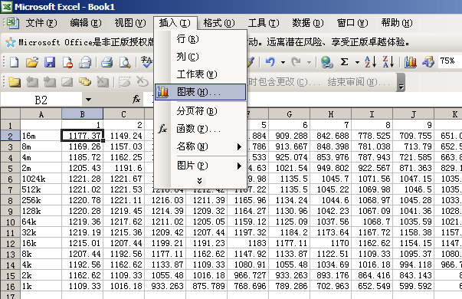

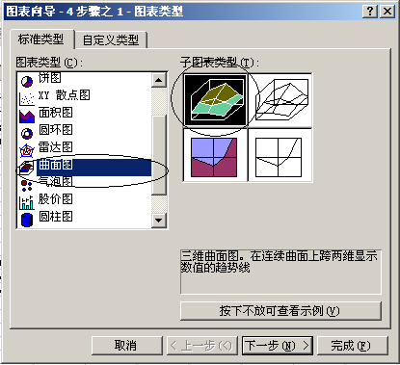

Then click Finish.

5．Then you can get a figure alike this:
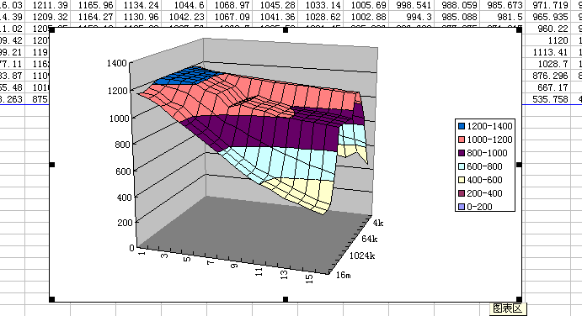

6. The following two figures are from CSAPP e1 and CSAPP e2
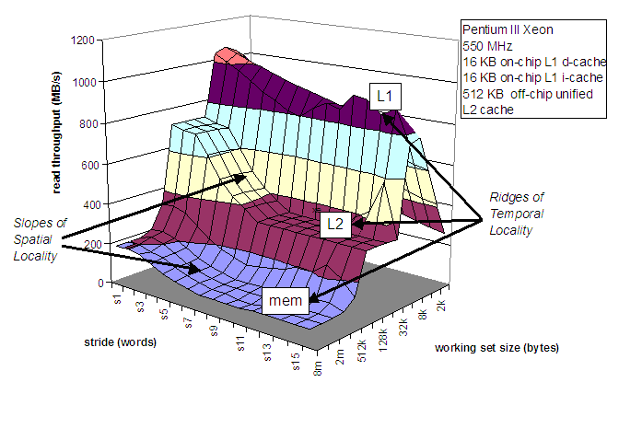
Figure of CSAPP e1

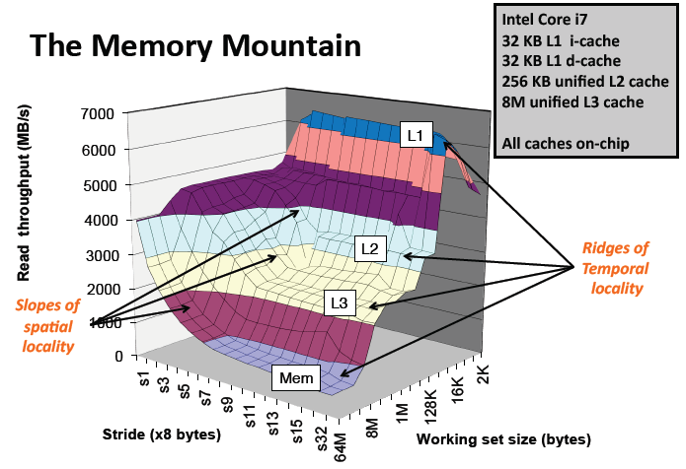
Figure of CSAPP e2

7．Just Paste your figure here:
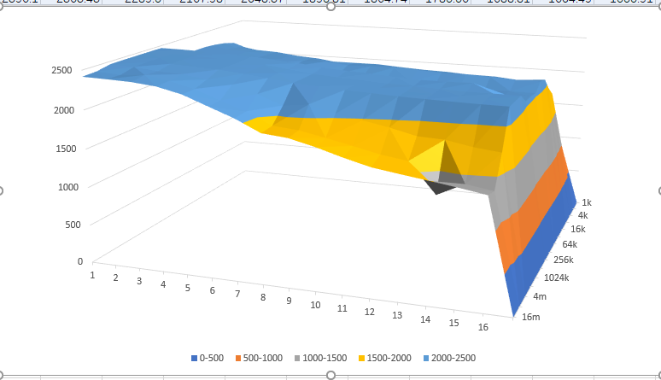

8．How many ridges(山脊) do you get? And what are they corresponding to?

4个山脊，分别对应着内存、L1、L2、L3

9．Just compare the mountain with the information that you just got by running as everest.exe. And explain How the spatial locality and temporal locality are shown in this figure.
1. 刚开始时，CPU吞吐量随着数据的增加而增加。由于此时L1缓存并未存满，根据时间局部性原理，刚被读取的数据块在不久的将来还会被读取，因此不会出现不命中的情况，吞吐量逐渐上升。
2. 数据到达32KB时，L1级缓存满了，此时增加数据会造成L1缓存的数据不命中，会使用L2级缓存，而L2速度低于L1，因此吞吐量会稍稍下降。持续增大数据，直到L2满了的时候，会使用L3，吞吐量再次下降。
3. 因为空间局部性，所以L2读取一块数据到L1时，会将临近的一块也放进L1，故随着stride的增大，命中率降低，吞吐量会逐渐下降。同样，L3放入L2时，也会将临近的一块一起放入，命中率降低，吞吐量下降。
4. 当stride增大到一定程度之后，每次只读取加载的那一块数据的字的大小的数据。所以当stride增大到一定值之后，命中率将不会再下降，吞吐量也将不会变化。

